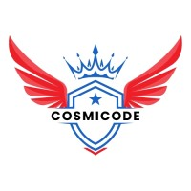
CosmiCode
Artificial Intelligence
Internship Module
Week 3: Problem Solving & AI Concepts (Intermediate)

Submitted To: Zarwish – CosmiCode HR
Submitted By: Haris Ali
Subject: Artificial Intelligence
Internship Module: Week 3
Date of Submission: 29/06/2025

Objective: Work on AI problem-solving strategies.
Tasks:
- Solve the Towers of Hanoi problem using recursion in Python.
SOLUTION:
def towers_of_hanoi(n, source, helper, destination):
if n == 1:
print(f"Move disk 1 from {source} to {destination}")
return
towers_of_hanoi(n - 1, source, destination, helper)
print(f"Move disk {n} from {source} to {destination}")
towers_of_hanoi(n - 1, helper, source, destination)

towers_of_hanoi(3, 'A', 'B', 'C')
OUTPUT:
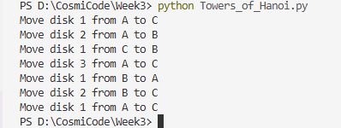
EXPLANATION:
We are solving Towers of Hanoi with 3 disks using 3 rods:
- A = source rod (where disks start)
- B = helper rod
- C = destination rod (where we want to move all disks)
Step-by-Step Explanation for n = 3
Step 1: Move top 2 disks from A to B (helper = C)
We call towers_of_hanoi(2, A, C, B)
1.1: Move top 1 disk from A to C
Call towers_of_hanoi(1, A, B, C)
Move disk 1 from A to C
1.2: Move disk 2 from A to B
Move disk 2 from A to B
1.3: Move disk 1 from C to B
Call towers_of_hanoi(1, C, A, B)
Move disk 1 from C to B
Step 2: Move disk 3 from A to C
Move disk 3 from A to C
Step 3: Move 2 disks from B to C (helper = A)
We call towers_of_hanoi(2, B, A, C)
3.1: Move disk 1 from B to A
Move disk 1 from B to A
3.2: Move disk 2 from B to C
Move disk 2 from B to C
3.3: Move disk 1 from A to C
Move disk 1 from A to C

- Create a Python program to implement a simple Tic-Tac-Toe game (player vs player).
SOLUTION:
import tkinter as tk
from tkinter import messagebox

root = tk.Tk()
root.title("Tic-Tac-Toe (Player vs Player)")

current_player = "X"
board = [["" for _ in range(3)] for _ in range(3)]
buttons = [[None for _ in range(3)] for _ in range(3)]

def check_winner():
for i in range(3):
if board[i][0] == board[i][1] == board[i][2] != "":
return True
if board[0][i] == board[1][i] == board[2][i] != "":
return True
if board[0][0] == board[1][1] == board[2][2] != "":
return True
if board[0][2] == board[1][1] == board[2][0] != "":
return True
return False

def is_draw():
for row in board:
if "" in row:
return False
return True

def on_click(row, col):
global current_player
if board[row][col] == "":
board[row][col] = current_player
buttons[row][col].config(text=current_player, state="disabled")
if check_winner():
messagebox.showinfo("Game Over", f"Player {current_player} wins!")
reset_game()
elif is_draw():
messagebox.showinfo("Game Over", "It's a draw!")
reset_game()
else:
current_player = "O" if current_player == "X" else "X"

def reset_game():
global board, current_player
board = [["" for _ in range(3)] for _ in range(3)]
current_player = "X"
for i in range(3):
for j in range(3):
buttons[i][j].config(text="", state="normal")

for i in range(3):
for j in range(3):
btn = tk.Button(root, text="", font=("Helvetica", 24), width=5, height=2,
command=lambda row=i, col=j: on_click(row, col))
btn.grid(row=i, column=j)
buttons[i][j] = btn

root.mainloop()

OUTPUT:
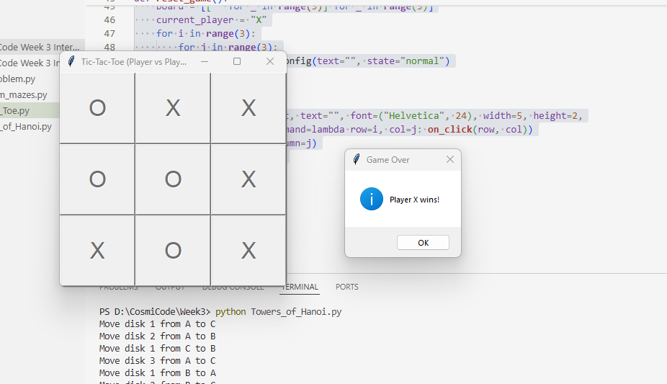
EXPLANATION:
- This program uses tkinter to create a window.
- It shows an N×N chessboard.
- It places queens (♛) safely using backtracking.
- The solution is drawn graphically:
- Gray and white squares like a real chessboard.
- Red queens are placed on safe positions.

- Create a program for N-Queens Problem using backtracking.
SOLUTION:
import tkinter as tk

def is_safe(board, row, col, n):
for i in range(row):
if board[i][col]:
return False
for i, j in zip(range(row-1, -1, -1), range(col-1, -1, -1)):
if board[i][j]:
return False
for i, j in zip(range(row-1, -1, -1), range(col+1, n)):
if board[i][j]:
return False
return True

def solve(board, row, n):
if row == n:
return True
for col in range(n):
if is_safe(board, row, col, n):
board[row][col] = 1
if solve(board, row + 1, n):
return True
board[row][col] = 0
return False

def draw_board(canvas, board, n):
canvas.delete("all")
cell_size = 50
for i in range(n):
for j in range(n):
x1 = j * cell_size
y1 = i * cell_size
x2 = x1 + cell_size
y2 = y1 + cell_size
color = "white" if (i + j) % 2 == 0 else "gray"
canvas.create_rectangle(x1, y1, x2, y2, fill=color)
if board[i][j]:
canvas.create_text(x1 + 25, y1 + 25, text="♛", font=("Arial", 24), fill="red")

def start_gui_solution(n):
board = [[0 for _ in range(n)] for _ in range(n)]
solve(board, 0, n)

window = tk.Tk()
window.title(f"{n}-Queens Solution")

canvas = tk.Canvas(window, width=50*n, height=50*n)
canvas.pack()

draw_board(canvas, board, n)
window.mainloop()

start_gui_solution(4)

OUTPUT:
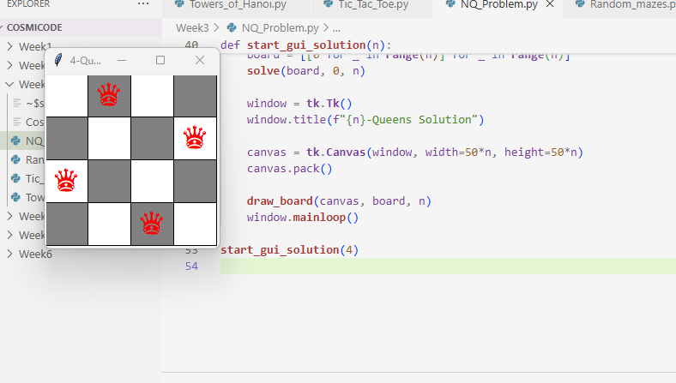
EXPLANATION:
- Solves the N-Queens problem using backtracking
- It finds a way to place n queens on an n x n chessboard so that no two queens attack each other
- The solve() function places queens row by row
- The GUI is built using tkinter
- It displays the solution with a chessboard and red queen symbols (♛)

- Write a Python program to generate random mazes and display them.
SOLUTION:
import tkinter as tk
import random
import time
from collections import deque

CELL_SIZE = 20
ROWS = 21
COLS = 21
DELAY = 0.01

def draw_cell(canvas, r, c, color):
x1 = c * CELL_SIZE
y1 = r * CELL_SIZE
x2 = x1 + CELL_SIZE
y2 = y1 + CELL_SIZE
canvas.create_rectangle(x1, y1, x2, y2, fill=color, outline=color)
canvas.update()
time.sleep(DELAY)

def generate_maze(canvas, maze, visited, r, c):
visited[r][c] = True
maze[r][c] = 0
draw_cell(canvas, r, c, "white")
directions = [(0, -2), (0, 2), (-2, 0), (2, 0)]
random.shuffle(directions)
for dr, dc in directions:
nr, nc = r + dr, c + dc
if 1 <= nr < ROWS - 1 and 1 <= nc < COLS - 1 and not visited[nr][nc]:
wall_r, wall_c = r + dr // 2, c + dc // 2
maze[wall_r][wall_c] = 0
draw_cell(canvas, wall_r, wall_c, "white")
generate_maze(canvas, maze, visited, nr, nc)

def solve_maze(canvas, maze, start, end):
queue = deque([start])
visited = [[False for _ in range(COLS)] for _ in range(ROWS)]
parent = {}
visited[start[0]][start[1]] = True
while queue:
r, c = queue.popleft()
if (r, c) == end:
break
for dr, dc in [(-1,0), (1,0), (0,-1), (0,1)]:
nr, nc = r + dr, c + dc
if 0 <= nr < ROWS and 0 <= nc < COLS and not visited[nr][nc] and maze[nr][nc] == 0:
visited[nr][nc] = True
parent[(nr, nc)] = (r, c)
queue.append((nr, nc))
draw_cell(canvas, nr, nc, "lightblue")
r, c = end
while (r, c) != start:
draw_cell(canvas, r, c, "yellow")
r, c = parent[(r, c)]

def main():
root = tk.Tk()
root.title("Maze Generator + BFS Solver")
canvas = tk.Canvas(root, width=COLS * CELL_SIZE, height=ROWS * CELL_SIZE, bg="black")
canvas.pack()
maze = [[1 for _ in range(COLS)] for _ in range(ROWS)]
visited = [[False for _ in range(COLS)] for _ in range(ROWS)]
generate_maze(canvas, maze, visited, 1, 1)
maze[0][1] = 0
maze[ROWS - 1][COLS - 2] = 0
draw_cell(canvas, 0, 1, "lightgreen")
draw_cell(canvas, ROWS - 1, COLS - 2, "red")
solve_maze(canvas, maze, (0, 1), (ROWS - 1, COLS - 2))
root.mainloop()

main()

OUTPUT:
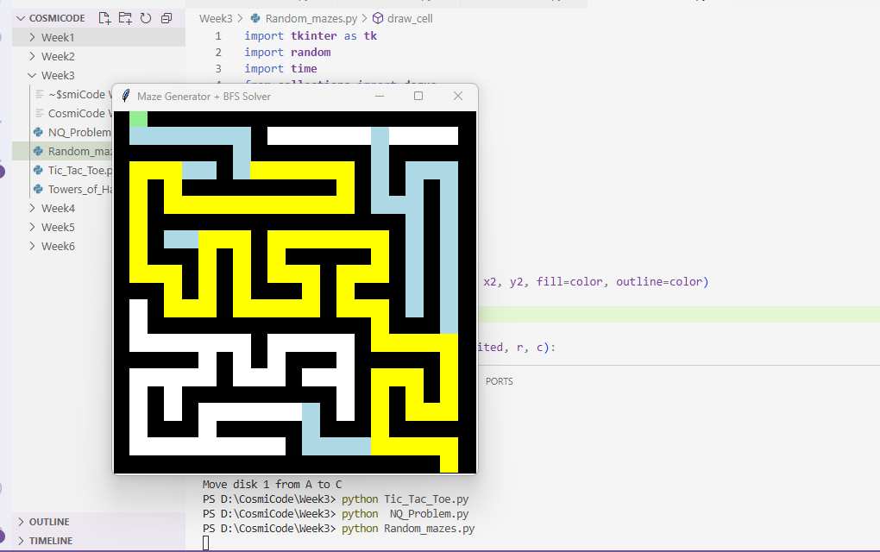
EXPLANATION:
- Generates a random maze using backtracking
- Shows it live using tkinter with white paths and black walls
- Adds a green start point (top) and red end point (bottom)
- Uses BFS (Breadth-First Search) to solve the maze
- Draws the search path in light blue
- Highlights the final solution path in yellow

- Write a research note (200-300 words) on Intelligent Agents and their types.
SOLUTION:
An intelligent agent is a system (like a program, robot, or software) that can sense its environment, think about what to do, and then take action to reach a goal. Just like a human makes decisions based on what they see or hear, intelligent agents use sensors (like cameras, microphones, or input data) to observe their surroundings and make smart choices.
For example, a self-driving car is an intelligent agent. It uses cameras and sensors to detect traffic and people, then decides when to turn, stop, or speed up. Similarly, digital assistants like Siri or Alexa listen to your voice and respond based on what you ask.
There are five main types of intelligent agents:
- Simple Reflex Agents: These work based on “if this, then that” rules. They react quickly but can’t learn or remember. Example: A thermostat that turns on heating if the temperature is too low.
- Model-Based Reflex Agents: These agents have a memory. They track what’s happening in the environment and respond better than simple reflex agents.
- Goal-Based Agents: These don’t just react; they aim for a specific goal. They check different paths and choose the one that helps them succeed.
- Utility-Based Agents: These agents look for the most efficient and best-quality solution, not just any solution. They compare options and choose what gives the most benefit.
- Learning Agents: These can improve over time by learning from past actions. For example, a recommendation system that gets better the more you use it.

